Procedure to Install SSMS of SQL Server 2014

Management Studio – First Approach
If you have the installation CD / DVD, then insert the installation media into the drive to install SQL Server. Within the root folder, double-click on the setup.exe as shown below.
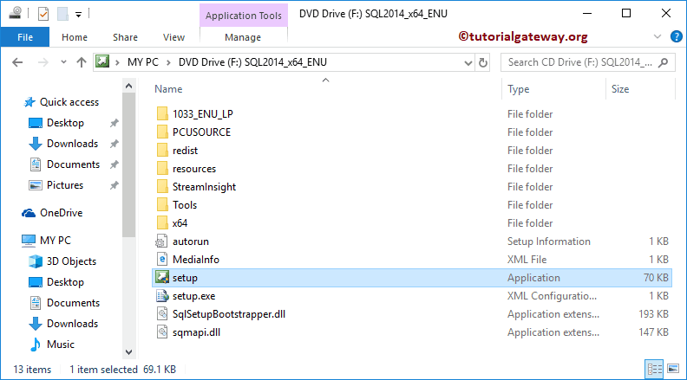
Once you click on the setup.exe, a new installation wizard called SQL Server Installation Center will be opened as we shown below. Next, go to Installation tab and click New SQL Server stand-alone installation or add features to an existing installation hyperlink
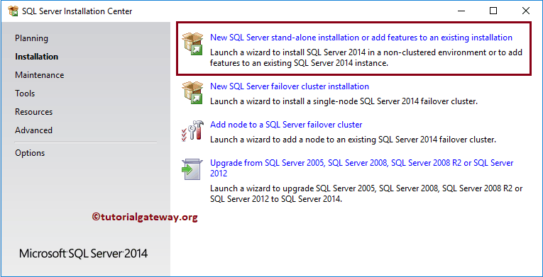
First the installation process will check for the updates
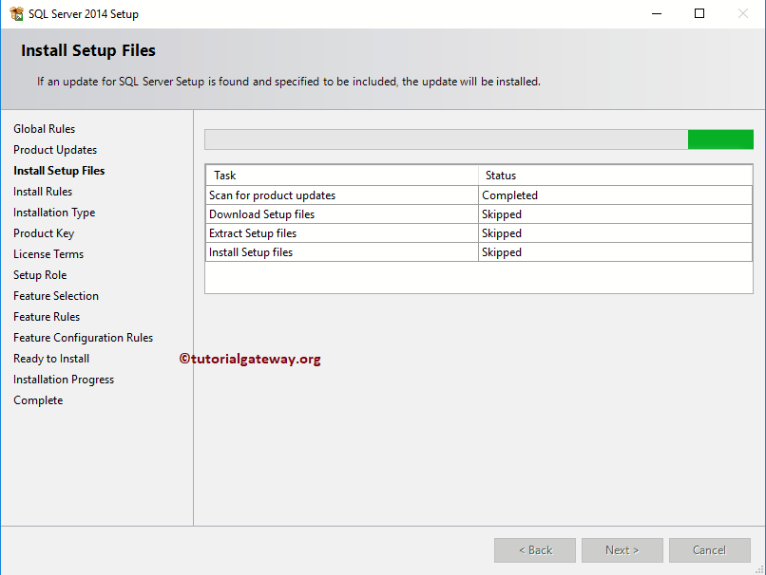
Next, it will enter into Install Rules window. And here, setup will automatically advances and perform the operations. Here, it has to pass all the rules present in this windows, but you can leave this Windows Firewall warning.
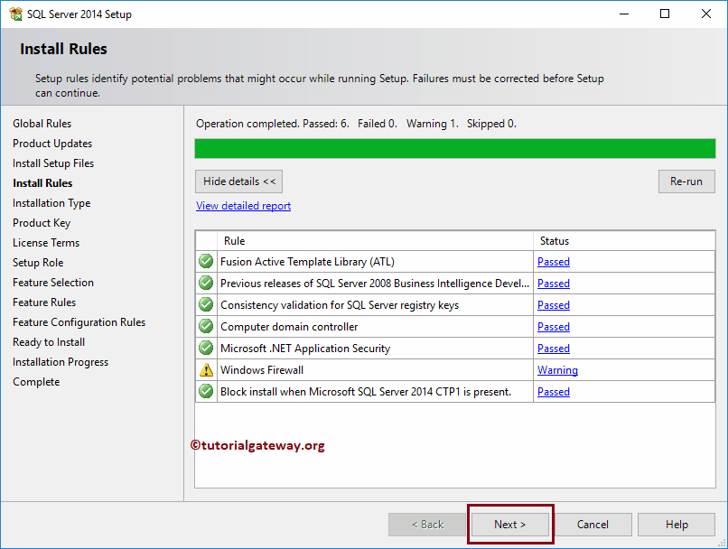
Once you click the Next button, it will enter into Setup page. Please select the second option i.e., Add Features to an existing instance of SQL Server because we want to add SQL Server management Studio to existing instance. Please refer Install SQL Server to understand the first option i.e installing SQL Server completely.
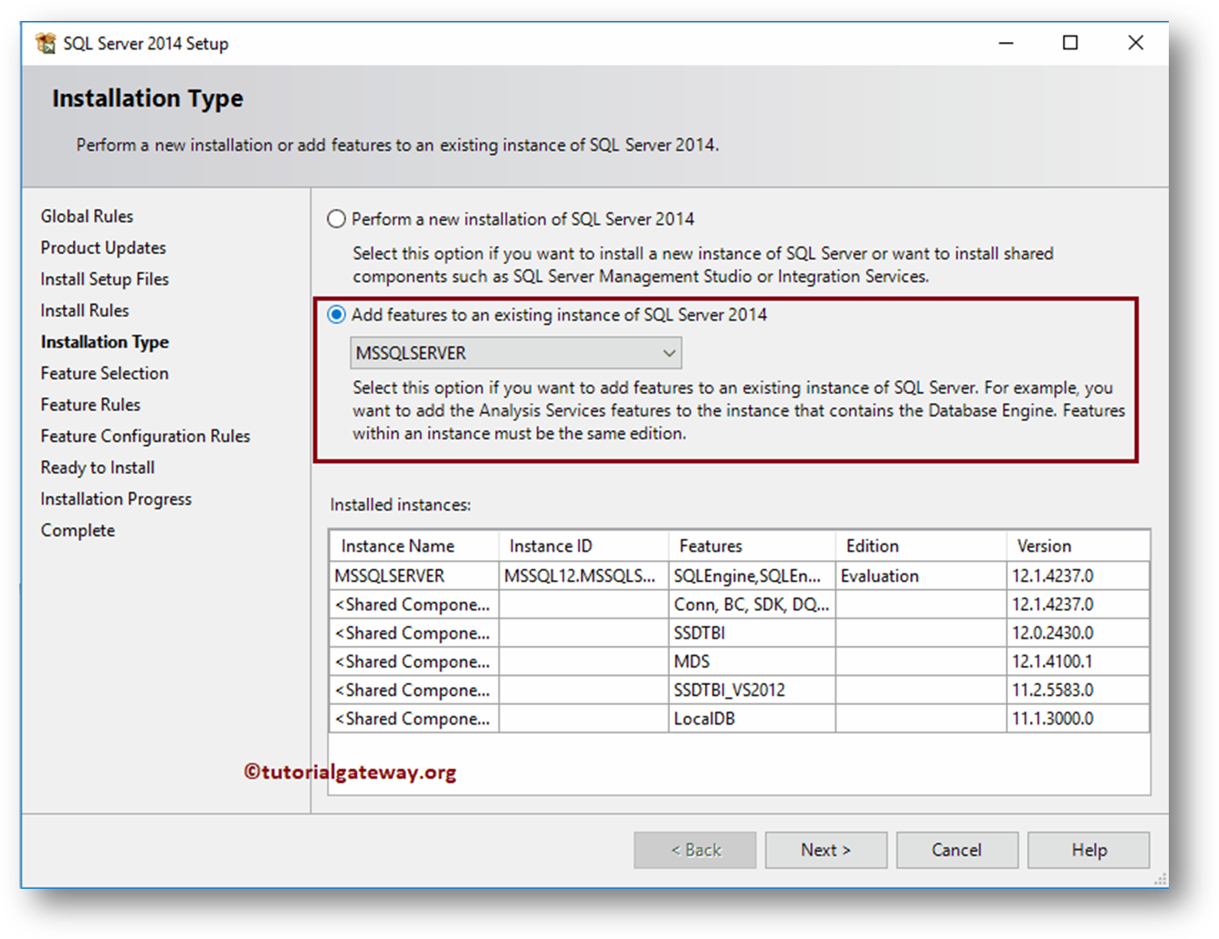
Feature Selection: Please select the features that you want to install into your computer. From the below screenshot, all the grayed out features are already installed in our local system.
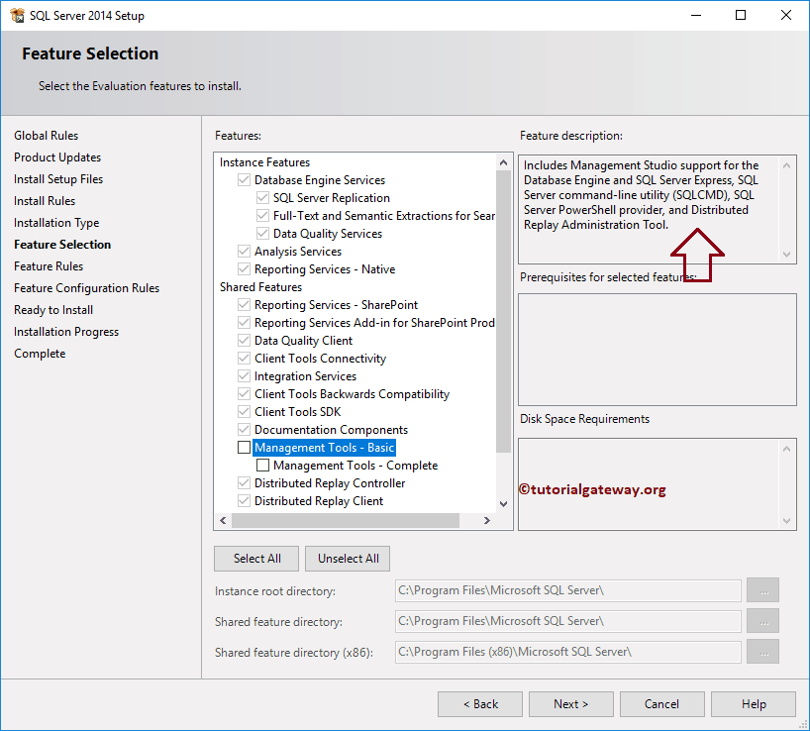
In order to install SQL Server Management Studio, Please check mark Management Tools – Basic, and Management Tools – Complete features and click Next button.
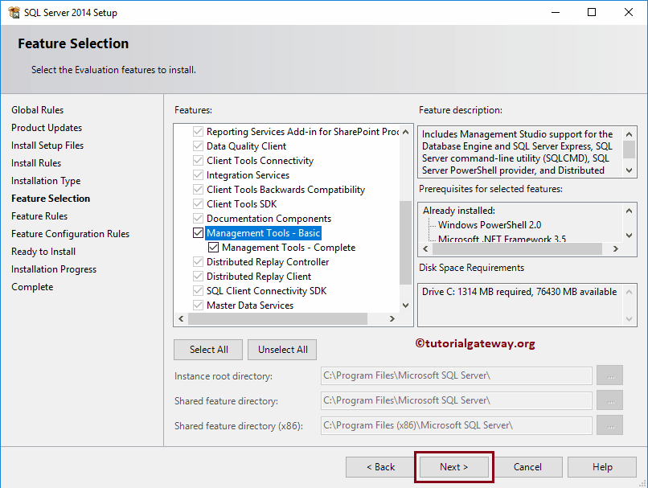
Click Install button
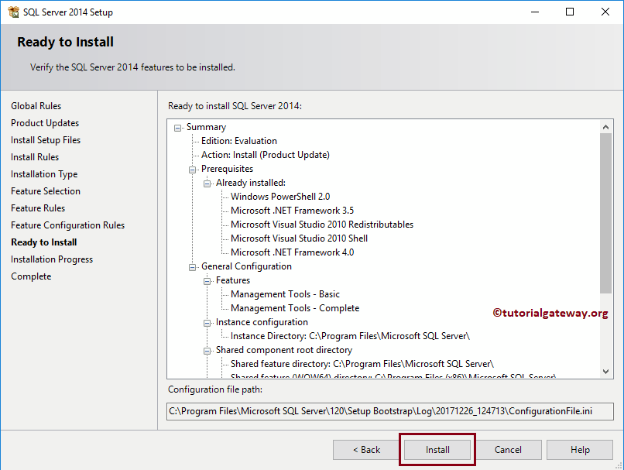
Allow few minutes to completely install SQL Server Management Studio
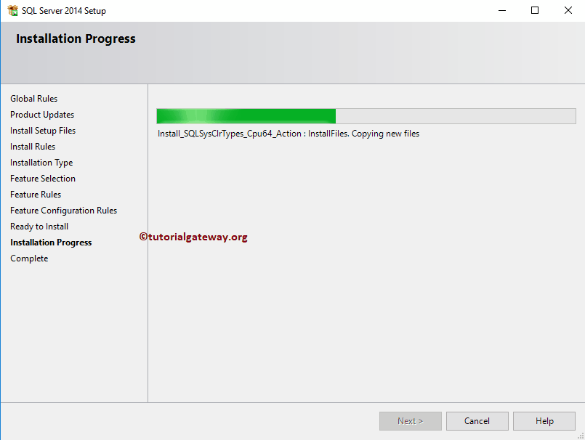
As you can see from the below screenshot, we successfully installed SQL Server Management Studio in our local system.
